|  |
| --- |
| zhe’s portfolio site |
| Zhe’s Portfolio site |
| Version 2.0  All work Copyright © 2015 by Zhe Yan.  All rights reserved. |
| **Zhe Yan 300706310** |
| **COMP 308-063** |

|  |
| --- |
| February 25, 2015 |

Table of Contents

Website Description 3

Desktop version 3

Mobile Version 3

Navigation Bar section 4

Desktop version 4

Mobile version 6

Colours section 7

Mobile version: 7

Typography section 8

Wireframes Section 10

Branding Section 14

# Website Description

## Desktop version

This is my portfolio site. It is using foundation to create a better appearance. It has 8 pages including home, contact me, project, about me, service and three project pages.

Home page has my welcome statement, tagline, mission statement. It shows viewer my mission and my goal. So viewer can have interest about me and have a look of my other pages.

Contact me page has a contact me form and my basic contact information. Viever can also easily follow me from social network icon in the bottom.

Project page is an overview of all the project I did before. It shows some images about my project and viewer can click either link of image to go to the detail page of each project.

About me page shows a little bit about myself and also my bio.

Since I am looking for a job. I put the service I can provide in the service page like software engineer and web developer.

And the three detail project page show the detail description of each project.

## Mobile Version

The mobile version are using JQuery mobile to create a customized view for mobile user. Navigation bar are redesigned,

The content of mobile version of my portfolio site is almost the same as the desktop version. Some content are condensed in the mobile version for the sake of easy to read.

I still have 8 pages in the mobile version site. Home page just show the welcome statement and demo work slider. About me page show my image and bio. Contact me page has a contact form, my contact number and also the social network panel.

Project page are almost the same, shows three images and user click each go to each project subpage. Service page described what kind of service I provide.

# Navigation Bar section

## Desktop version

The following pictures shows my navigation of portfolio site:

In the large screen:

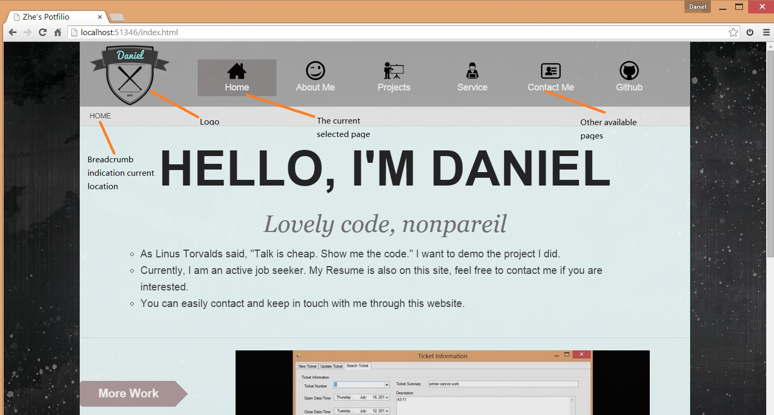

In the medium screen:

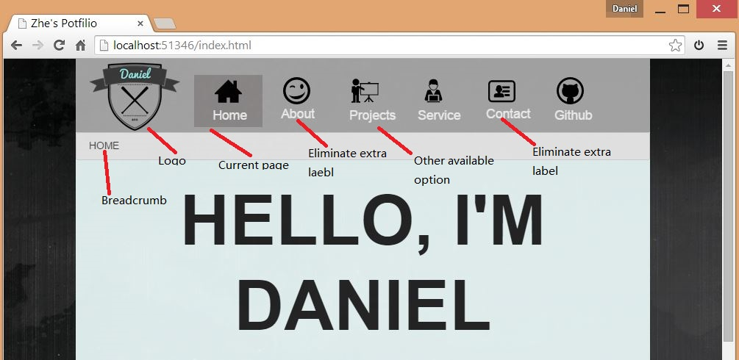

In the small screen

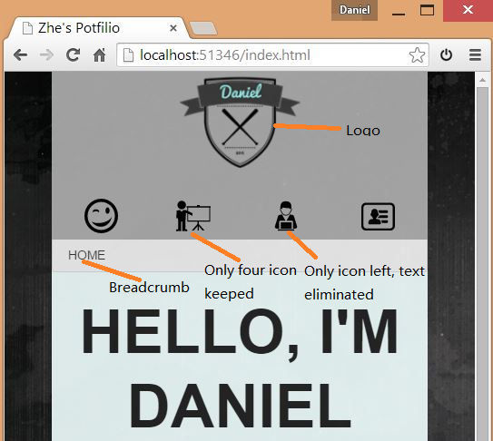

As you can see from the diagrams above, the navigation will change based on screen.

Basically I am using an icon bar navigation in this site.

In the large screen, navigation will show 6 icons: Home, About me, projects, service, contact me and GitHub. And also full text will be showed in the large screen size. And my logo is in the left side of navigation. Breadcrumbs are below the navigation bar. After click each navigation item. Website will direct to corresponding webpage. And in different webpage, navigation will shows the page that is “Active” with a slight different color.

In the medium screen, I eliminate some label words in the navigation bar. So the appearance of navigation will be consistent.

In the small screen condition, since we have limited space in the screen. I eliminate the label (words) of navigation bar and also just keep four main navigation items which is meaningful to keep in small screen condition.

## Mobile version

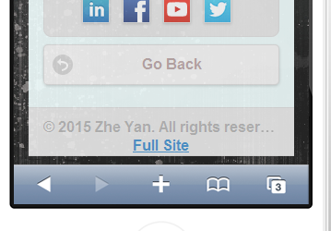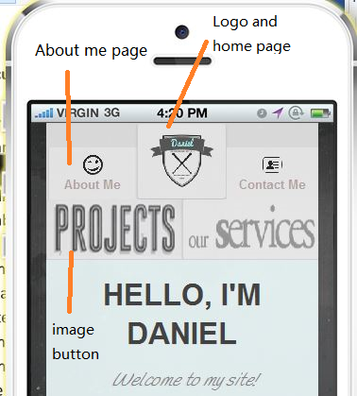

The navigation bar redesigned for the mobile site, the logo also served as the home button. And button for project and service changed to a enhanced image button for better appearance.

As you can see from the picture in the right hand side. Some of pages also have another go back button in the bottom of page to provide visitor convenience to go back.

# Colours section

 Examples of sites colours

|  |  |  |
| --- | --- | --- |
| Used place | colours  (swatches) | hexadecimal  values |
| Project page contact button, index page call to action button, Contact me page submit button |  | b59f9f |
| Project page contact button hover, icon bar hover,call to action button hover, |  | 966d6d |
| Navition bar background, |  | b0b0b0 |
| Checked navigation item |  | 949191 |

Mobile version:

Theme roller screenshot

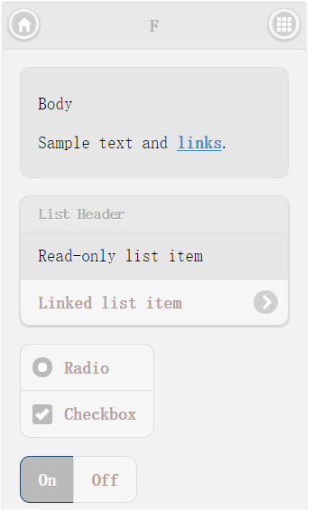 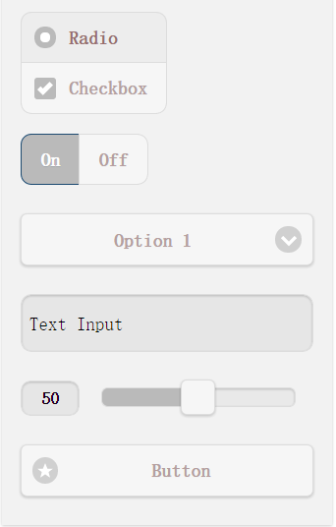

|  |  |  |
| --- | --- | --- |
| Used place | colours  (swatches) | hexadecimal  values |
| home page welcome statment |  | 767474; |
| Subheader color, Tagline color |  | 767474; |

# Typography section

## Desktop Version

Screen capture:

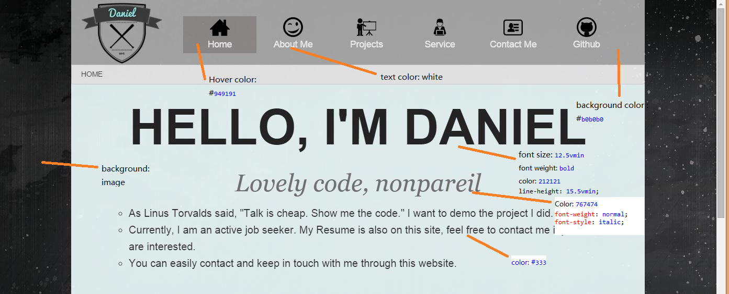

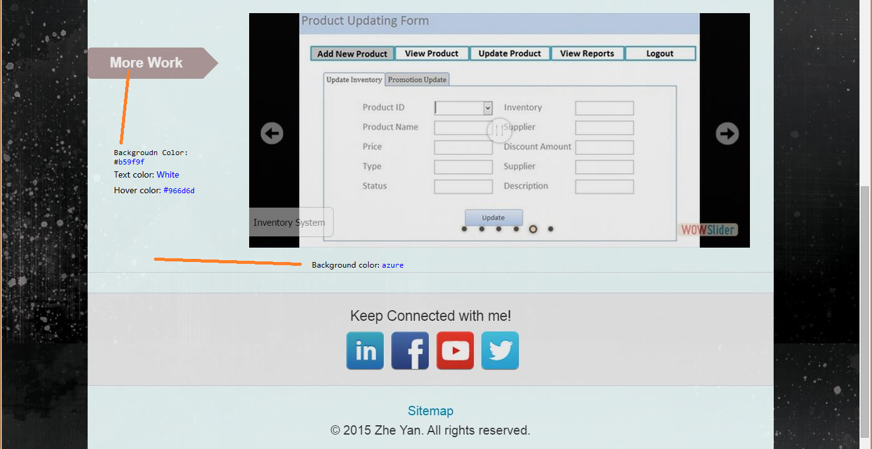

Table summary of Typography

|  |  |
| --- | --- |
| Used place | Font, size, colours |
| Navigation bar checked item color |  |
| Navigation bar text color | white |
| Navigation bar background color |  |
| Welcome statement | Color:  font-weight: bold;  font-size: 12.5vmin;  line-height: 15.5vmin; |
| Tagline style | color:  font-style: italic;  font-family: Georgia, "Times New Roman", Times, serif;  font-weight: normal; |
| Paragraph and mission statement | Color: |
| Call to action button | Color:  Hover color:  Text color: white |
| Wrapper background color |  |

## Mobile Version

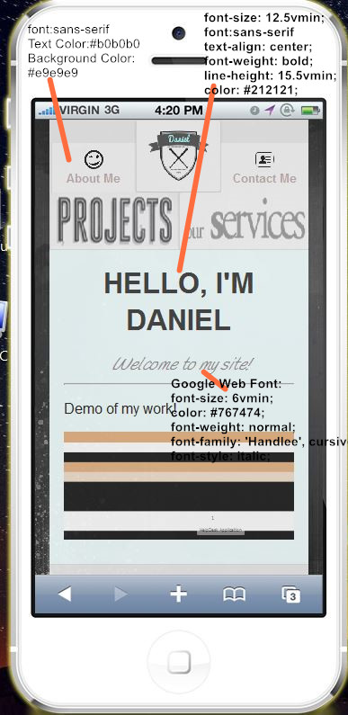

Table summary of Mobile home page Typography

|  |  |
| --- | --- |
| Used place | Font, size, colours |
| Navigation bar checked item color | #bababa |
| Navigation bar text | Color:  Font:San-serif |
| Navigation bar background color | #e9e9e9 |
| Welcome statement | Color:  Font:sans-serif  font-weight: bold;  font-size: 12.5vmin;  line-height: 15.5vmin; |
| Tagline style | Google Web Font:  font-family: 'Handlee', cursive;  font-size: 6vmin;  color:  font-weight: normal;  font-style: italic; |
| Wrapper background color |  |

# Wireframes Section

## Desktop Version

The home page (index.html) wireframe

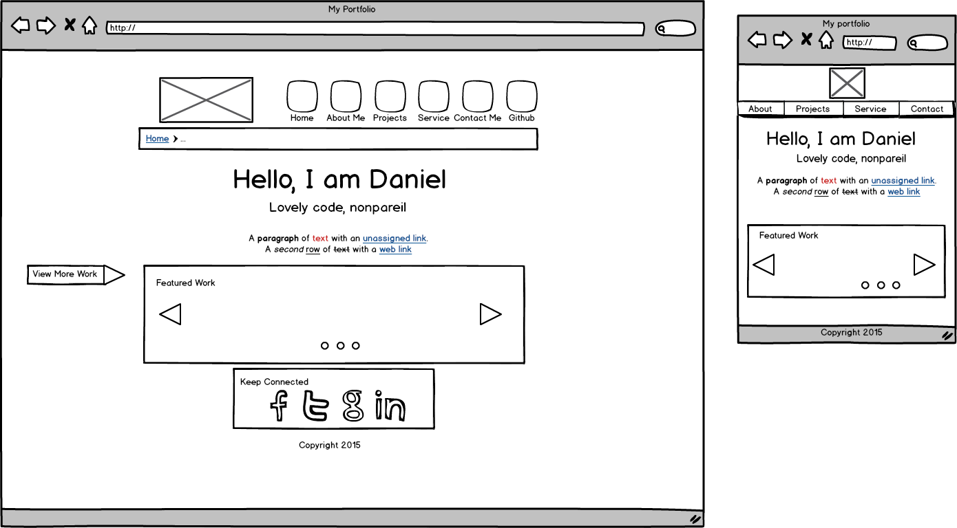

About me page wireframe:

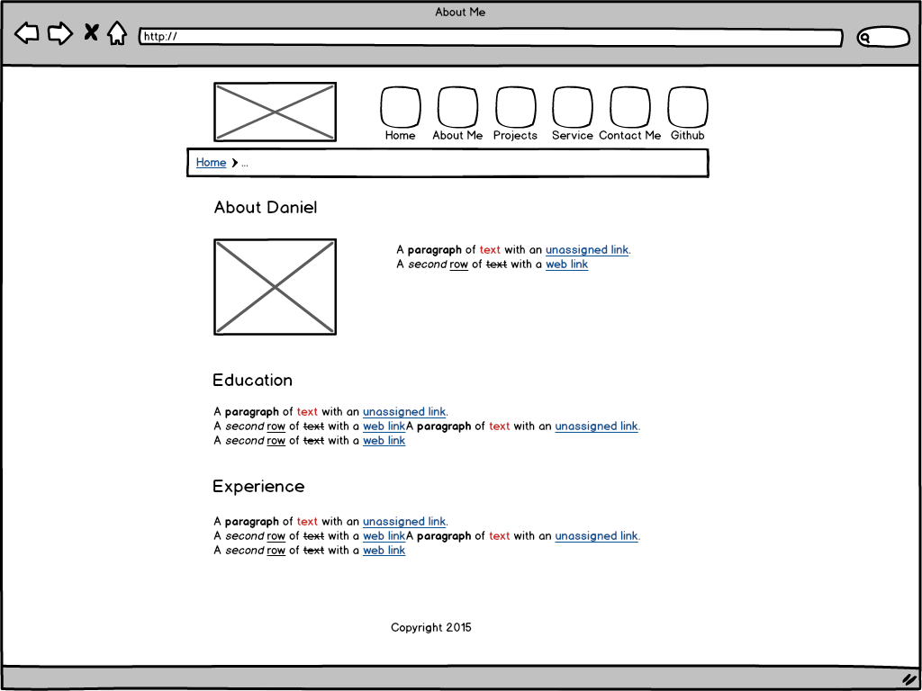

Project page wireframe:

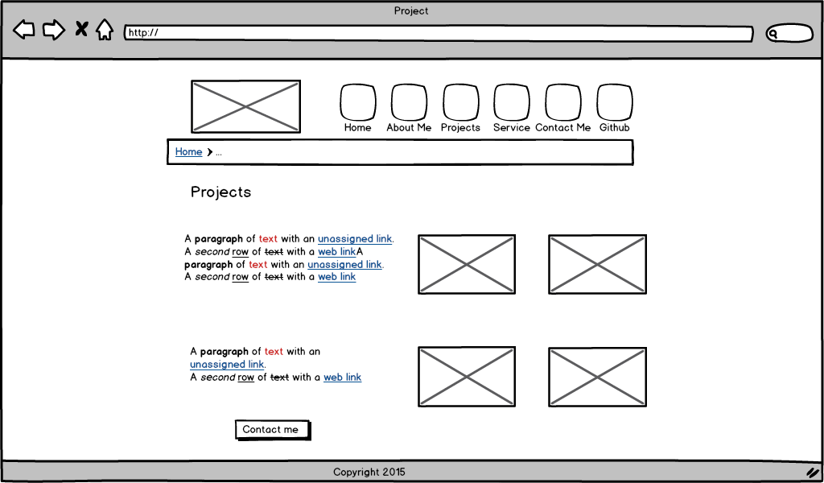

Service page wireframe:

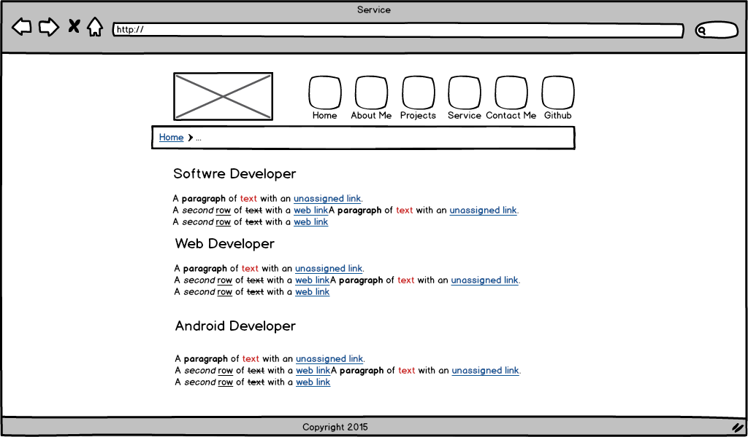

Contact me page wireframe:

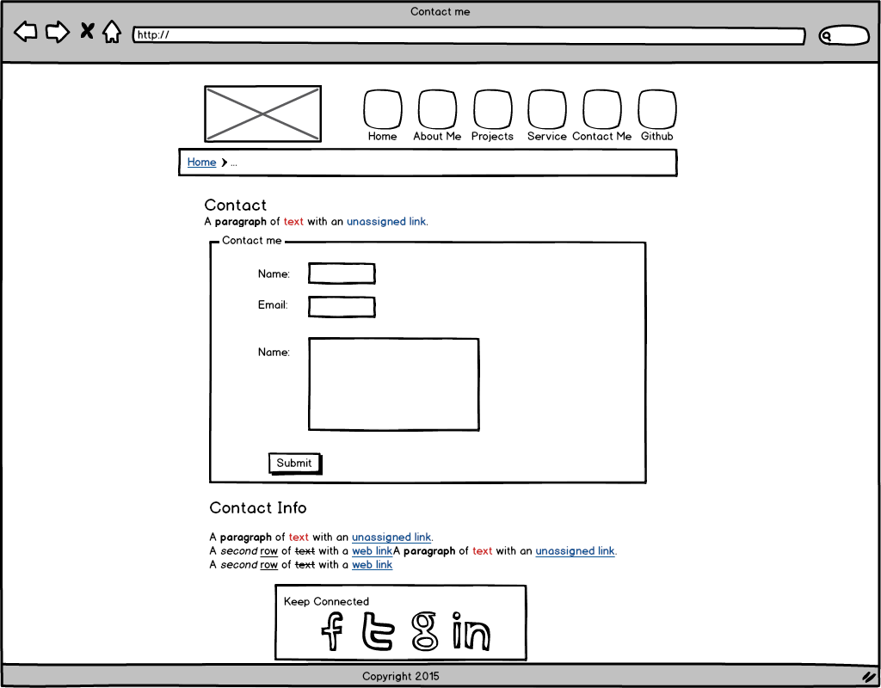

## Mobile Version:

Home page:

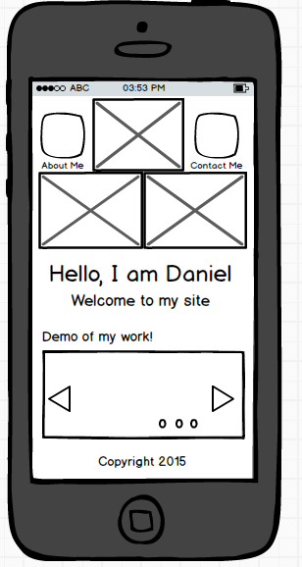

About Me page:

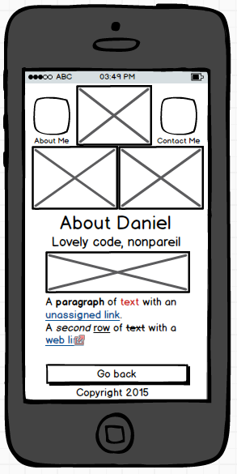

Contact Me page:

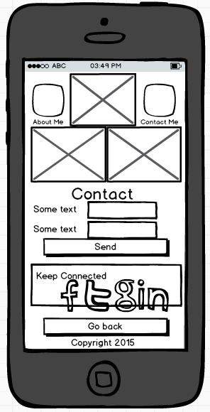

Project page:

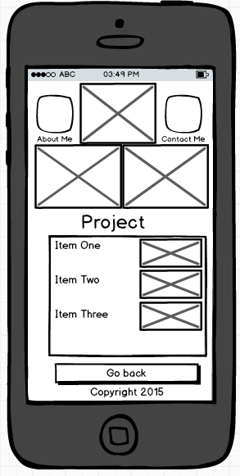

Service page

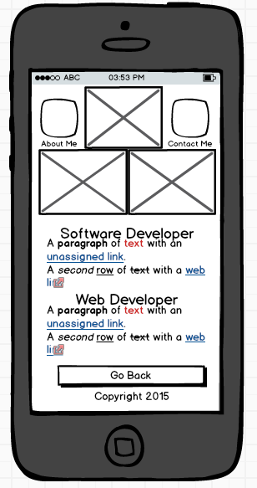

# Branding Section

## Mobile Version

My Logo:



Home page: 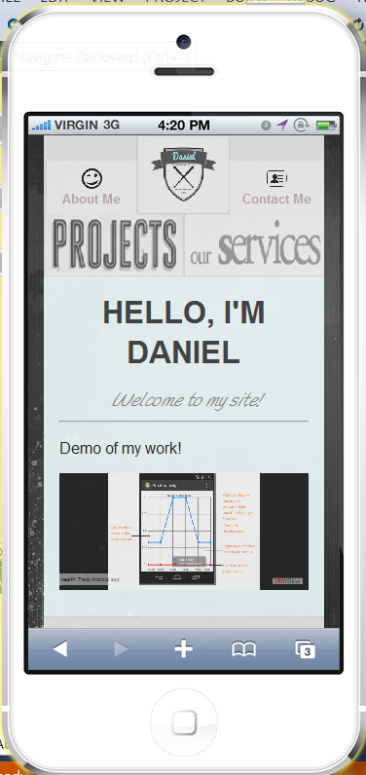*About Me page:*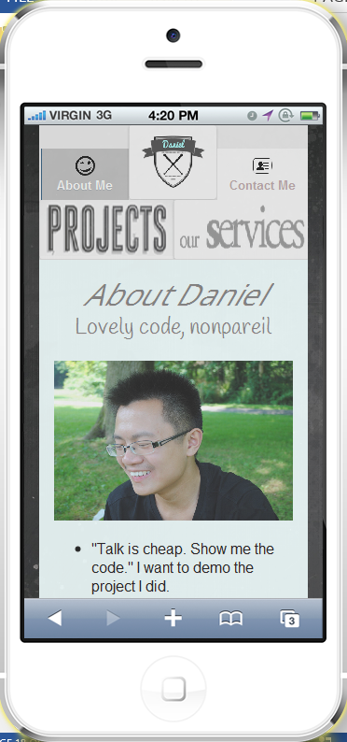

*Contact Me page:*

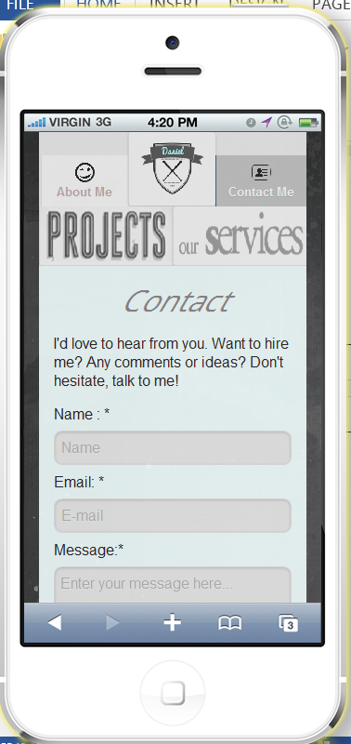

*Project page:*

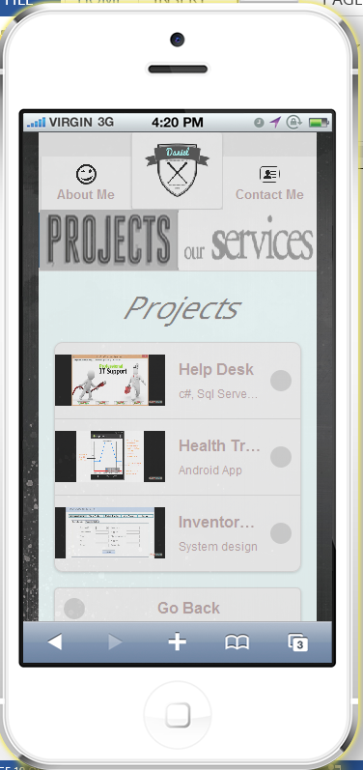

*Project Subpage:*

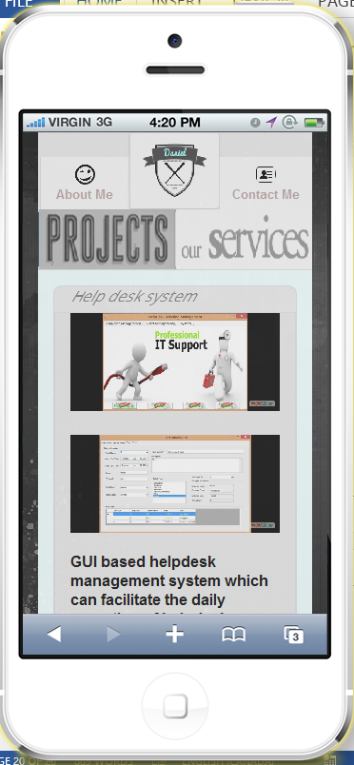

*Service page:*

